SIMATS ENGINEERING
SAVEETHA INSTITUTE OF MEDICAL AND TECHNICAL SCIENCES
CHENNAI – 602105
Department of Computer Science and Engineering

ASSESSMENT TOOL 1 – DATA CLEANING CHALLENGE

Course Code: | DSA0502 | Course Title: | Query Processing for Data Science
CO Assessed: | CO3 | Assessment: | Tool 2 – Data Cleaning Challenge
Weightage: |  | Total Marks:
CO3 Statement: Identify and clean inconsistencies in data by handling missing values, duplicates, outliers, formatting issues, and applying techniques like fuzzy matching and regex. (BL5 and BL6).
Student Name: | SIDDARTH P | Reg. No.: | 192324264
Section / Batch: | 2023 | Date of Submission: | 9-08-2026
Faculty In-charge: | Dr. B.Shyamala Gowri | Project Mode: | Individual Submission

Code of Conduct
I SIDDARTH.P / 192324264 (Name / Reg No) certify that this submission is my original work and that I have adhered to all guidelines specified for this assessment. I understand that any violation of academic integrity rules will result in disciplinary action.
Signature: _SIDDARTH P_

Anomaly Detection  (5 Marks) | Cleaning Methods  (5 Marks) | Data Transformation  (5 Marks) | Analytical Comparison  (5 Marks) | Governance Discussion  (5 Marks) | Total (25 Marks)

Question 3: Banking Loan Approval Dataset

A bank uses the loan-application dataset (L001–L010) to decide loan eligibility. The raw file contains eight distinct data-quality problems — a missing credit score, income recorded in mixed units, a negative loan amount, a duplicate customer record, an under-age applicant, inconsistent employment-status labels, an extreme income outlier, and a missing income value. Each is diagnosed, cleaned with a justified rule, and the downstream effect on the loan-approval decision is measured below.

Task 1. Critical Issues Affecting Loan Decisions
Every issue below directly touches a field that risk-scoring or eligibility logic depends on, so each is classified by the type of decision it could corrupt if left uncleaned.
Issue | Record(s) | Impact on Loan Decision
Missing CreditScore | L003 | Risk-scoring model receives a null feature — the record may be auto-rejected or silently dropped from the model instead of being properly assessed.
Income in mixed units ("900K") | L002 | If "900K" is read as the literal number 900, the debt-to-income ratio explodes, causing a wrongful rejection of an eligible applicant.
Negative LoanAmount | L004 | A negative principal breaks EMI, interest and exposure calculations downstream (e.g. in portfolio risk aggregation).
Duplicate CustomerID / full row (L008 repeated) | L008 | Double-counts one applicant's exposure and inflates the approval rate reported to management (see Task 4).
Under-age applicant (Age = 16) | L005 | Loans cannot legally be extended to a minor. An "Approved" status on this row is a compliance violation, not just a data glitch.
Inconsistent EmploymentStatus ("FT", "Full Time", "fulltime") | L002, L003, L008 | If treated as separate categories, a rules engine or ML model under-weights the true size of the "Full Time" segment, skewing risk scoring.
Extreme income outlier (₹7.5 Cr) | L007 | Almost certainly an extra zero typed in; if trusted as-is it inflates the applicant's eligible loan amount far beyond a safe multiple of income.
Missing AnnualIncome | L010 | Income-to-loan and debt-to-income ratios cannot be computed at all, so eligibility cannot be assessed until the gap is resolved.

Task 2. Cleaning Techniques for Missing & Inconsistent Data
Issue | Technique | Why this technique
Income unit mismatch ("900K") | Regex-strip suffix, map K → ×1,000, then cast to float | Preserves the true value instead of discarding the row; a parsing rule is reusable for future "K/L/Cr" entries.
Missing CreditScore (L003) | Median imputation (median of the other 8 scores = 700) | Median resists the effect of any remaining outliers better than the mean; avoids deleting an otherwise valid applicant.
Negative LoanAmount (L004) | abs() — treated as a sign-entry error, not a real negative loan | Domain knowledge: a negative loan amount has no real-world meaning, so it is corrected rather than nulled or dropped.
Duplicate record (L008) | drop_duplicates() on the full row | Exact duplicate, so removing the second copy is safe and does not lose information.
Employment status variants | Case-fold + dictionary map {"FT":"Full Time", "fulltime":"Full Time", ...} | Guarantees every record lands in one of a fixed, known set of categories before it reaches any scoring logic.
Under-age applicant (L005, age 16) | Flag as "Invalid — Manual Verification Required"; do NOT impute an age | Age determines legal identity/eligibility. Inventing a plausible age would fabricate a fact about a real person — this must go to manual/compliance review instead.
Missing AnnualIncome (L010) | Median imputation (₹8,25,000, computed after removing the duplicate) | Keeps the record usable for aggregate reporting while being flagged separately wherever an individual eligibility decision is made.
Core of the cleaning pipeline (Python / pandas):
def fix_income(v):
if pd.isna(v): return np.nan
v = str(v).strip().upper()
return float(v[:-1]) * 1000 if v.endswith('K') else float(v)
emp_map = {'FT':'Full Time', 'FULLTIME':'Full Time', 'FULL TIME':'Full Time',
'PART TIME':'Part Time', 'SELF EMPLOYED':'Self Employed', 'UNEMPLOYED':'Unemployed'}
df['AnnualIncome'] = df['AnnualIncome'].apply(fix_income)
df['EmploymentStatus'] = df['EmploymentStatus'].str.upper().map(emp_map)
df = df.drop_duplicates(subset=['CustomerID','AnnualIncome','CreditScore','LoanAmount','Age'])
df['LoanAmount'] = df['LoanAmount'].abs()
df['CreditScore'] = df['CreditScore'].fillna(df['CreditScore'].median())
df.loc[df['Age'] < 18, 'ReviewFlag'] = 'Underage - Manual Verification Required'
df['AnnualIncome'] = df['AnnualIncome'].fillna(df['AnnualIncome'].median())

Task 3. Outlier Detection & Treatment
The IQR method is applied to AnnualIncome (after de-duplication and median-imputing L010), since income is the field that most directly drives loan-eligibility limits.
Statistic | Value | Note
Q1 (25th percentile) | ₹6,50,000 | 9 records, linear interpolation
Q3 (75th percentile) | ₹12,00,000 | 9 records, linear interpolation
IQR = Q3 − Q1 | ₹5,50,000 | —
Upper bound = Q3 + 1.5×IQR | ₹20,25,000 | Any income above this is flagged

ID | Income (raw) | Flag | Income (cleaned) | Action
L001 | ₹7,50,000 | Normal | ₹7,50,000 | None
L002 | ₹9,00,000 (parsed) | Normal | ₹9,00,000 | Unit-fixed
L003 | ₹12,00,000 | Normal | ₹12,00,000 | None
L004 | ₹1,50,000 | Normal | ₹1,50,000 | None
L005 | ₹50,00,000 | Outlier | ₹20,25,000 | Capped
L006 | ₹4,50,000 | Normal | ₹4,50,000 | None
L007 | ₹7,50,00,000 | Outlier | ₹20,25,000 | Capped
L008 | ₹6,50,000 | Normal | ₹6,50,000 | None
L010 | Missing | Missing | ₹8,25,000 | Median-imputed

L005 (₹50L) and L007 (₹7.5 Cr — almost certainly an extra zero typed in) both exceed the ₹20.25L upper bound and are capped, not deleted at the upper bound. Capping keeps the applicant in the risk pool (dropping real customers would bias any model trained on this data) while preventing the extreme value from distorting income-based eligibility limits.

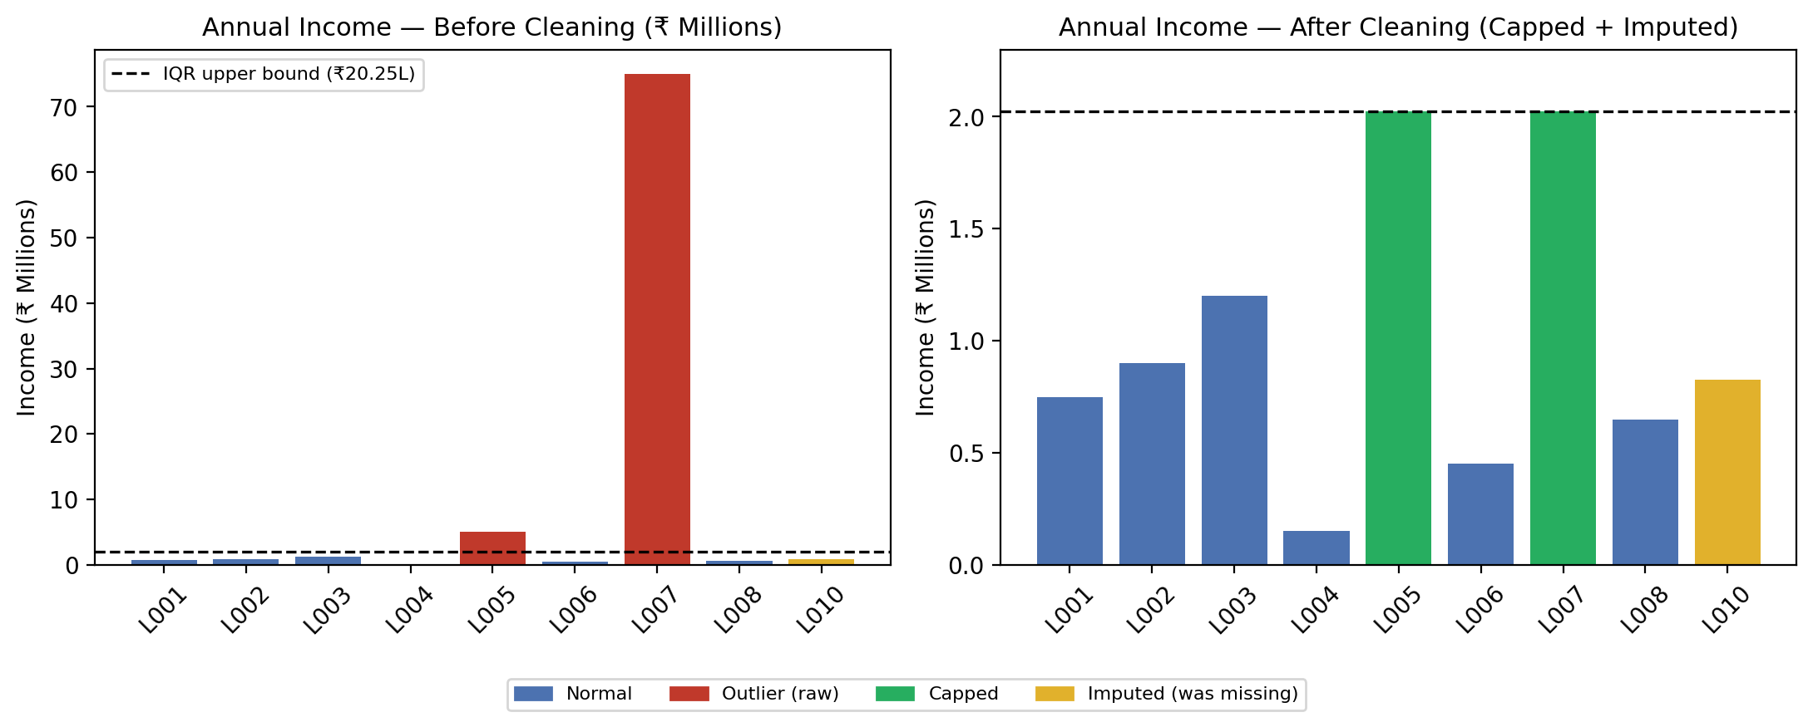
Annual income before vs after IQR-based capping (L010 shown in amber as a median-imputed, not capped, value).

Task 4. Effect of Cleaning on Loan Approval Rate
Stage | Approved | Total Records | Rate
Before cleaning (raw, incl. duplicate L008, incl. under-age L005 as Approved) | 8 | 10 | 80.0%
After de-duplication only | 7 | 9 | 77.8%
After de-duplication + flagging L005 (under-age → Hold, not Approved) | 6 | 9 | 66.7%

The reported approval rate drops from 80.0% to 66.7% once cleaning is applied correctly. Two separate corrections drive this: removing the duplicate L008 record (which had silently double-counted one approval), and re-classifying L005 out of "Approved" because a 16-year-old cannot legally hold the loan. Either correction alone changes the headline number reported to management — together they show how uncleaned data can materially overstate approval performance and mask a compliance breach.

Task 5. Ethical Implications of Incorrect Cleaning Decisions
- Fabricating values for a compliance-critical field is worse than leaving it missing — imputing a fake age for L005 to make it look like a valid adult applicant would conceal a legal violation rather than fix a data error; such rows must be flagged for manual review, never silently corrected.
- Capping vs deleting outliers changes who is represented in the data: deleting L005 and L007 outright would remove real applicants from the risk pool and could bias any model trained on the "cleaned" data toward safer-looking customers only.
- Every imputed or corrected value (credit score, income, employment label) must be logged with the rule that produced it, so the pipeline is auditable if a rejected or approved applicant later disputes the decision.
- Cleaning rules must be applied consistently across every applicant. Applying a stricter or looser rule to a specific individual or group — even unintentionally — turns "data cleaning" into a form of discriminatory selection.
- Silent duplicate removal changes reported business metrics (approval rate, exposure); stakeholders should be told what was removed and why, not just shown the revised number.

